1. What is Monolith Architecture?

Used by traditional web apps (old approach).

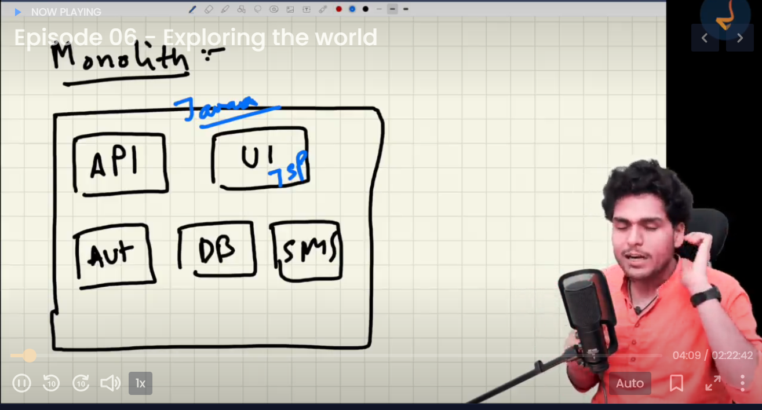

1. What is Microservice Architecture?

Independent services are written which together form a complete project. These services interact with each other. This is known as separation of concerns (Single Responsibilities principles).

1. useEffect will be called after the component is rendered.
2. What is shimmer UI?
3. What is Diffing and Reconciliation process in React?